Database Course - **Assignment 3**                   **Due date: June.17th**

Consider the LIBRARY relational schema shown below, which is used to keep track of books, borrowers, and book loans. Referential integrity constraints are shown as directed arcs.

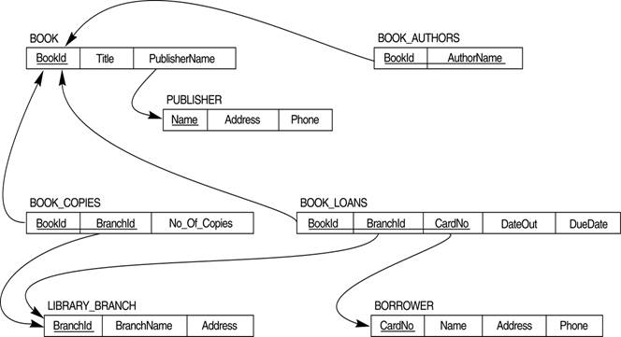**Part I : Tables + Constraints**

Write *create-library.sql* script which has SQL statements for creating the tables and constraints for the library database system.

**Constraints**: Be sure to include primary keys, and foreign keys. The data types of tables for the most part are self explanatory. I will explain the ones which are little ambiguous. All the IDs such as BookId, BranchId, and CardNo are integers. DateOut and DueDate columns are of type DATE which indicate date a book is loaned out and date a book is due respectively. In Oracle, columns of type DATE stores date and time. Include a constraint such that DueDate is one month from the date a book is loaned out. Enforce users to require a value for book title, branch name, and borrower name. The number of copies of a book should be a positive value.

**Part II : Data Manipulation**

Load each of your tables with at least 10-15 rows (more is better), and include your insert statements in a separate file titled *insert-library.sql*.

**Submission**: Create a Zip file and submit electronically using [http://d2l.mu.edu](http://d2l.mu.edu/). Make sure you use exactly the given file names (for .sql files) when you submit because my grading script is sensitive to those names. Also submit some screen shots/test runs of your oracle sql developer executions showing your table creations, constraint validation checks, and sample data in your tables for parts 1 and 2.